WEEKLY PROGRESS REPORT
AI Document Extraction & ArXiv Agent Project
Week: March 09 – 13, 2026
Reported | Safiullah Omar
Project | Physics LLM

1. Weekly Summary
Focused on laying the foundation for the document extraction system — designed the initial agent workflow, built the ArXiv agent prototype, and aligned on requirements with Vinh .

2. Tasks Completed
Architectural Workflow Design
- Designed the initial architectural workflow for document extraction using a basic agent flow
- Adopted a modular fan-out/fan-in pattern: Query Parser → ArXiv Search → parallel sub-agents → Response Aggregator
- Researched state-of-the-art approaches (Microsoft DocLens, LayoutLM family) to inform design decisions
ArXiv Repositories Agent
- Designed the ArXiv agent that reads user queries and returns answers based on metadata from ArXiv API
- Agent translates natural language queries into structured ArXiv search parameters (title, author, abstract, category, date)
- Responses include paper titles, authors, abstracts, publication dates, and direct ArXiv links
Initial Code Development
- Developed the initial codebase for the ArXiv agent with modular project structure
- Implemented core query parsing logic and ArXiv API integration layer
- Built metadata extraction and response formatting modules
- Used async request handling, JSON schema for inter-agent data exchange, and error handling for API rate limits

3. Meetings
Meeting Log
Mon, Mar 09 | Meeting with Vinh — Discussed the initial workflow design, agreed on the agent-based pipeline approach, and identified ArXiv agent as the first proof-of-concept deliverable.
Mid-week | Follow-up with Vinh — Reviewed smaller sub-agents within the ArXiv pipeline, clarified initial requirements (query scope, metadata fields, output format), and discussed edge cases.

4. Agent Workflow Diagram
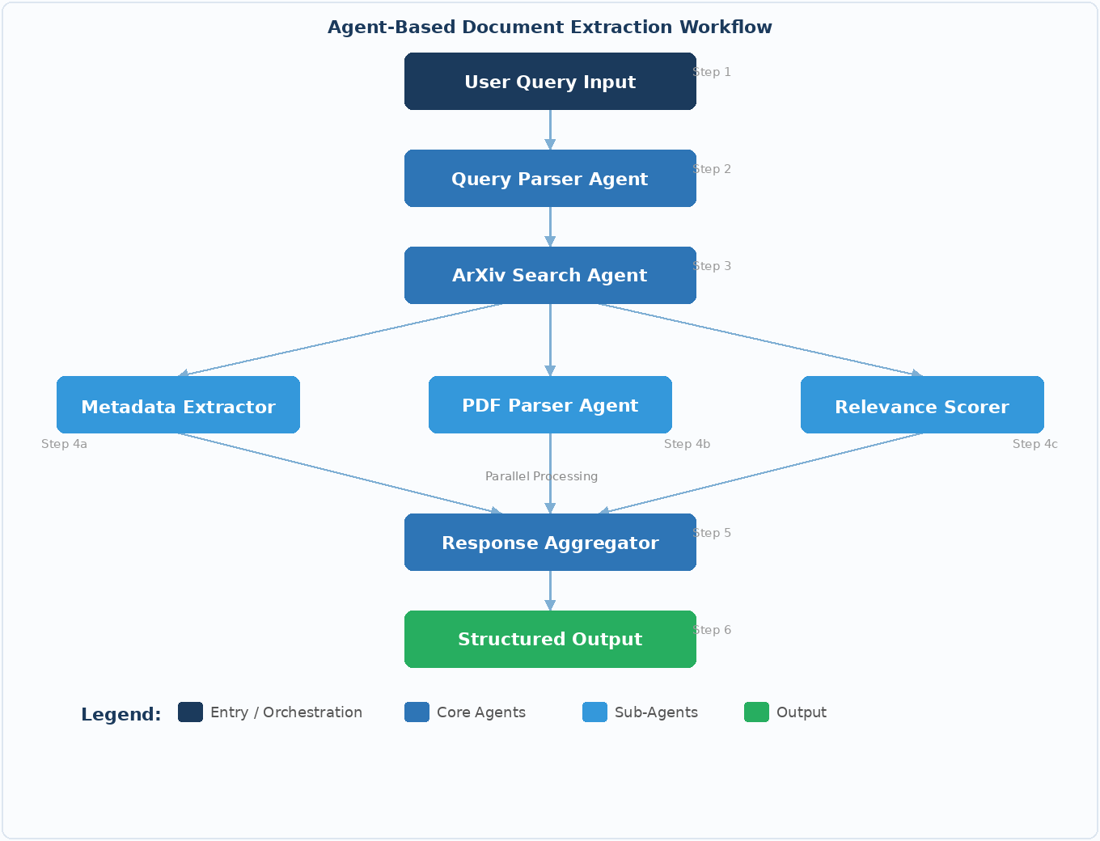
Figure 1: Agent-Based Document Extraction Workflow
Key Components
Query Parser Agent | Interprets user query, extracts keywords/filters, creates structured API parameters
ArXiv Search Agent | Executes search against ArXiv API, retrieves candidate papers and raw metadata
Metadata Extractor | Extracts and normalizes bibliographic metadata (authors, title, abstract, dates, DOI)
PDF Parser Agent | Downloads and parses PDF content — text, tables, figures, equations
Relevance Scorer | Ranks results by semantic relevance to the original query
Response Aggregator | Combines, de-duplicates, and formats the final structured output

5. Status Overview
Progress
Task | Status | Notes
Architectural Workflow Design | ✅ Done | Initial version
ArXiv Agent Design | ✅ Done | Design finalized
ArXiv Agent – Initial Code | ✅ Done | First iteration
Meetings with Vinh | ✅ Done | 2 sessions completed
PDF Parser Agent | 🟡 Next | Planned next week

6. Plan for Next Week
- Extend ArXiv agent with advanced query support (multi-field search, date filtering, category filters)
- Begin PDF Parser Agent implementation for full-text content extraction
- Refine Metadata Extractor for edge cases identified in discussions
- Start Relevance Scorer module development
- Demo review meeting with Vinh

7. Challenges
- ArXiv API rate limiting and inconsistent metadata formatting — addressed in error-handling layer
- Balancing agent granularity vs. system complexity — current design is a pragmatic middle ground

